CSEE 4240 Wireless Sensor Networks Project
Friend or Foe Identification
Jasper Yu
5/5/2014

Wireless Sensor Networks Project Proposal

Introduction
Wireless networks usually comprise of a “variety of stationary sensors spread across a geological area” (Barclay et al., 2008). These stationary sensors are commonly referred to as nodes, and each are commonly tasked with monitoring and recording specific data from the node’s current environment. The data each node collects is subsequently transmitted to a gateway, which in turn can be transmitted to some other area like a web server (Barclay et al., 2008).
There are a plethora of areas where the use of wireless sensor networks can be applicable. Such areas may consist of, but are not limited to air quality, humidity detection in deserts, forest fire detection, water quality, natural disaster prevention, machine health, etc. It is important to note that much of these applications are useful in bettering the general public health and/or lifestyle. Specifically speaking, these wireless networks can be used to prolong and save lives.
Why is this important? It is believed that these such networks can be used for military purposes. As written in the 2008 paper, Theoretical and practical aspects of military wireless sensor networks, “wireless sensor networks can be used by the military for a number of purposes such as monitoring militant activity in remote areas and force protection” (Barclay et al., 2008). The paper goes further by explaining that using the “appropriate sensors, these networks can enable detection of enemy movement, identification of enemy forces and analysis of movement and progress” (Barclay et al., 2008).
Imagine a scenario where some country’s military is planning the invasion of some strategic target. Rather than sacrificing soldiers to gather military intelligence by sending scouting parties, military command could opt for another route by sending unmanned vehicles. These vehicles can be equipped with multiple sensors that could be placed in secluded areas to monitor troop movement or even relay crucial data that may determine the outcome of the ensuing battle. Real time friend or foe identification also has the potential to greatly increase combat capability and cohesion. This would greatly decrease the number of deaths caused by friendly fire.
Sensor/Network Requirements
A network of this size and magnitude will require thousands of sensors nodes. This means that these nodes are expected to be, cheap, durable, lightweight, and small (Barclay et al., 2008). Every node is also expected to function for a prolonged period of time to ensure the successful identification and subsequent survival of each individual solder. The paper, Theoretical and practical aspects of military wireless sensor networks, highlights three key aspects of this type of sensor network. It has to have a “tailored routing and transport protocol,” “short distances between each node,” and “special-purpose operating system” (Barclay et al., 2008). For this project, a special operating system will not be needed.
Due to the harsh nature of the environment these sensors will be introduced to, they have to meet certain physical requirements. Each node will have to travel with an individual soldier, which means that the size of each node has to be kept as small as possible. They also have to be as unobtrusive as possible to ensure that they do not hinder the soldier in anyway or prohibit the soldier from accomplishing a mission. Each node must be able to “rapidly identify neighbors within communications range and configure themselves into a network”(Barclay et al., 2008). The location of each soldier should be recorded and mapped so every soldier's position is known. This particular aspects is extremely important because failure to identify each node may lead to friendly fire and unnecessary casualties. The node must be able to identify whether or not the soldier is in a life threatening situation, I.e, whether or not the soldier has been shot. These sensors are attached to the soldier's person as soon as they arrive on the battlefield, thus there should be little to no configuration needed. Once the sensor has been securely attached, they should be able to function for a period of “one or two months”(Barclay et al., 2008).
Sensor Constraints
Due to the quality and number of sensors available, some of these requirements are not achievable. The need for thousands of sensors may prove to be difficult because of the nature of Zigbee networks. There can only be one Coordinator active at any time. This limits the area of which data can be transmitted. Also, the functional distance of each radio assuming there are no obstructions are very limited. This means it will take significantly longer to transmit data from router to coordinator the farther a router is from the coordinator. Power will also be an issue. Each node is expected to run for at least one or two months (depending on how long the soldier on the battlefield), so a battery may not have enough power.
Network Architecture
Every node will consist of an Arduino Uno and various sensors. These sensors include the TMP 36 Temperature Sensor, Force Sensitive Resistor, and GPS. Each Arduino will also be equipped with an XBee Series 2 radio that will serve as the primary form of communication. As stated above, the node should be able to monitor the soldier's state of health. Two TMP 36 Temperature Sensors will be deployed to constantly monitor two variables. The first variable will be the temperature of the air. The second variable is the temperature of the soldier. The air temperature will serve as a reference point for the second variable. The soldier's internal body temperature is usually higher than that of the air temperature, which means that if the soldier's body temperature drops significantly lower than that of the air temperature, the soldier may have died. If that is the case, the radio address will be recorded and the body will be tagged for retrieval.
The force sensor will be able to determine whether or not the soldier is taking fire. If a bullet were to collide with body armor, the force sensor will sense this impact and update the database accordingly alerting team leaders that someone in their squad has been hit. Of course, this sensor isn't just specific towards small arms fire. If the soldier were to suffer from blunt force trauma, or is subjected to any potential life threatening force, team leaders or anyone with authority will be alerted.
The XBee Series 2 radios have two main functions. The first function is to package and transmit data to the gateway, and subsequently the server. The second function is to detect whether there are other radios in the vicinity. The radio addresses being sent to the XBee will be compared to other addresses stored in a whitelist to determine whether or not that XBee is friendly. This second function is crucial in determining the soldier's identity through the radio address. If the soldier's identity is confirmed, he will be tagged as friendly and the likelyhood that other soldiers or unmanned air vehicles/unmanned ground vehicles will target him will decrease.
The PIR sensor will work in conjunction with the XBee radio to determine whether or not there are friendly units nearby. For example, when the soldier is sleeping, and someone moves towards the soldier, movement will be sensed and the system will work to identify whether or not that person is friendly or not. If the person is not friendly, the soldier will be alerted immediately.
While the soldier is deployed in a battle zone, his location will be monitored with a GPS that is connected to the node he is wearing. The GPS will constantly send the soldier's current position so that other friendly units nearby will know his present location. This may potentially serve two purposes. If the soldier is killed, his body can be easily retrieved because his body can be found near his last transmitted coordinates. In the event the soldier becomes disoriented and loses contact with his squad, he can easily locate them and reorient himself. At the same time, in the event a squad is under heavy fire and requires support, other squads can rush to their aid in a swift and timely manner. This demonstrates the ability for rapid deployment and reinforcement, and has the potential to save numerous lives as well as resources.
Performance Specifications
The TMP36 Temperature Sensor is specified to sense temperatures from -40°C to 125°C. It does not require any external calibration to provide accuracies of ±1°C at 25°C and ±2°C over the -40°C to 125°C interval. It is rated for anything between 2.7 and 5V, and the supply current runs below µA while providing self generated heat of less than 0.1°C. This sensor outputs 750mV at 25°C and has an output scale factor of 10mv/°C as shown in Figure 1 (Low Voltage Temperature Sensors).
The Force Sensing Resistor has a greater than 100kΩ resistance at zero applied force to a 10kΩ resistance at maximum allowed applied force as seen in Figure 2. This sensor can measure upwards of 10kg, which is the saturation point, but this saturation point is related more to a function of pressure rather than force. That being said, this pressure function is close to 100 to 200 psi. The pressure range is about 1.5 to 150 psi or 0 to 22 lbs (0 to 9.97 kg). The force accuracy ranges from ±5% to ±25% depending on measurement consistency. It can only take an applied current of 1mA per square centimeter of applied force (Force Sensing Resistor Integration Guide and Evaluation Parts Catalog).
The XBee Series 2 radios has a range of 40 meters indoors and 120meters outdoors without any obstructions to its line of sight. The transmitting power for each individual radio is 2mW, and the TX and RX current is both 40mA at 3.3V. It operates at the 2.4 GHz frequency band is is FCC approved. It can operate on a supply voltage between 2.8 and 3.4V (XBee Series 2 OEM RF Modules).
The GPS can track up to 66 satellites at one time. It has one-second navigation and has low power consumption. It operates at 3.3V with a 41mA current. This GPS also updates up to 10Hz, but it performs best at about 5Hz (GPS Receiver).
The PIR sensor can take 5-12V. It will take about 1-2 seconds to calibrate. The alarm pin will require a pull up resistor which allows multiple sensors to be connected on a single input pin. If any motion is detected, the input pin will be pulled low (PIR Motion Sensor).

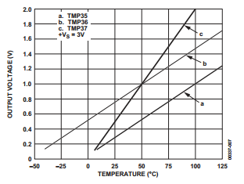
Figure 1 Vout vs Temperature (Low Voltage Temperature Sensors)

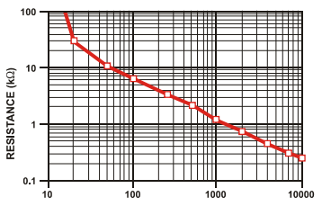
Figure 2 Resistance vs Force (Force Sensing Resistor Integration Guide and Evaluation Parts Catalog)
Information Management System
There will be two databases that are located in sensornetworks.engr.uga.edu. The first database will be a “whitelist” repository that stores the radio address and name of a soldier. The point of having a whitelist is so that everytime a radio address is being read, it can be compared to whatever is stored on the database to determine whether someone is a friend or a foe.
The second database (“datalog” will store all relevant sensor data. Such data will be the force applied to the soldier, body temperature, air temperature, longitude, latitude, and date/time. The last value is important for people monitoring the progress of a battlezone to determine how recent the sent data is that way reinforcements or fire support can be directed to the correct location in a timely manner.
A php web interface is also available for ranking officers to add or remove radio addresses from the database. They can also view the current whitelist and the entirety of the datalog database. This will allow them to monitor the current state of each individual soldier. After each battle, there is an option to clear the datalog database to avoid any confusing in subsequent battles.
System Testing
Overall, the temperature sensor and force sensor are fairly accurate within a few degrees from what was specified above (Figure 3). The temperature sensor was able to get decent readings of the air temperature, but it took some time for the second temperature sensor to measure the body temperature. This should not be an issue, however, because the second sensor should always be in contact with the soldier. The PIR sensor, however, is very sensitive. Any subtle motion will set it off, so this sensor is not very reliable. It's still able to capture motion though, but if this sensor were to be used in the field, it is very like that the result will be the opposite of what is trying to be achieved. Unfortunately, the GPS could not be used. It seemed like it was unreliable as attempts to configure the GPS resulted in values that were just “*” characters. Putting the GPS outside and waiting for usable data also ended in failure, as the “*” kept repeating. After about one to one and a half day(s) of testing/troubleshooting, it was decided that the GPS was unusable. The Xbees have a very short range. Anywhere outside room 314C may result in losing radio signal, but they are very good at transmitting data when signal can be found . As seen in Figure 3, the data is being logged at a consistent rate, and the changes in sensor values affect the values of each column. For example, when the body temperature is not equal to the air temperature, the soldier is alive. It is important to note that an arbitrary force was chosen to represent the force of a bullet impact for demonstration. In this specific case the value 150 was chosen, and as seen below, when the value exceeds 150, the soldier is drawing small arms fire. A battery might not be able to keep this system powered for more than a day or two if used continuously.
As for the user experience , the overall system may be a little too bulky for comfortable wear. However the user interface (Figure 4) makes adding and removing users very easy. It also makes viewing the log easy as well. The log is designed to sort the table according to date and time, with the most recent time being on top, and the least recent time being at the bottom. This allows for easier tracking of personnel. At the same time, because data is being transmitted constantly, it may be extremely difficult to track more than one person at a time. In order to efficiently track all users, a new interface will need to be developed.
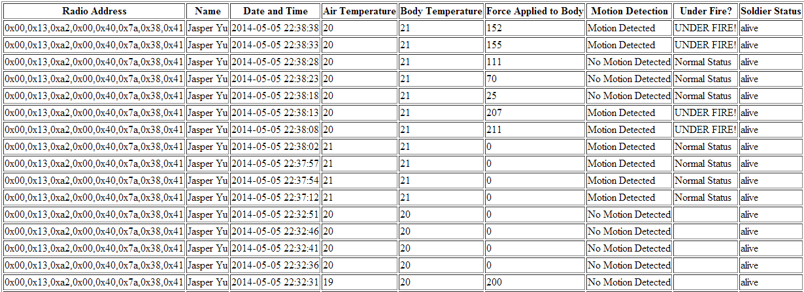
Figure 3 Datalog

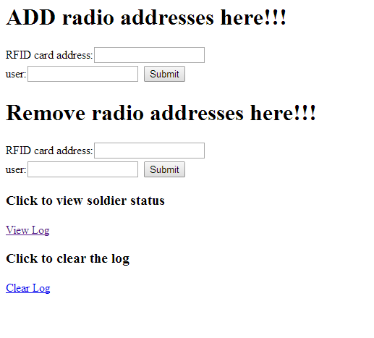
Figure 4 User Interface

Works Cited
"Force Sensing Resistor Integration Guide and Evaluation Parts Catalog." N.p., n.d. Web. 5 May 2014.
"GPS Receiver - LS20031 5Hz (66 Channel)." - GPS-08975. N.p., n.d. Web. 05 May 2014.
"Low Voltage Temperature Sensors." N.p., n.d. Web. 5 May 2014.
"PIR Motion Sensor." - SEN-08630. N.p., n.d. Web. 05 May 2014.
Winkler, Michael , Klaus-Dieter Tuchs, Kester Hughes, and Barclay Graem. "Theoretical and practical aspects of military wireless sensor networks." Journel of Telecommunications and Information Technology: n. pag. Web. 10 Apr. 2014.
"XBee Series 2 OEM RF Modules." N.p., n.d. Web. 5 May 2014.

